REPORT ON SLEEP ANALYSIS DATASET PROCESSING & ANALYSIS

1. Overview & Objectives
The objective of this analysis was to investigate the relationships between physical attributes (body weight, brain weight, max life span, gestation time) and environmental/survival factors (predation index, sleep exposure index, danger index) relative to the total sleep duration in various mammal species.

2. Data Preprocessing & Cleaning
The original dataset consisted of 62 rows and 8 variables. The following data-cleaning steps were performed using Python (pandas, numpy):
- Handling Missing & Invalid Values: Several numerical columns (total_sleep, gestation_time, max_life_span) contained non-numeric placeholder characters (such as ?). These were converted into numeric values, coercing invalid entries into NaN values.

- Data Type Casting: Updated column data types to appropriate floating-point and integer formats to allow for mathematical and correlation calculations.

- Missing Value Removal: Rows containing missing values across key variables were dropped, resulting in a cleaned dataset (sleep_analysis1) containing 58 complete animal observations.

3. Descriptive Statistics Summary
Based on the cleaned dataset of 58 species, key statistical metrics include:
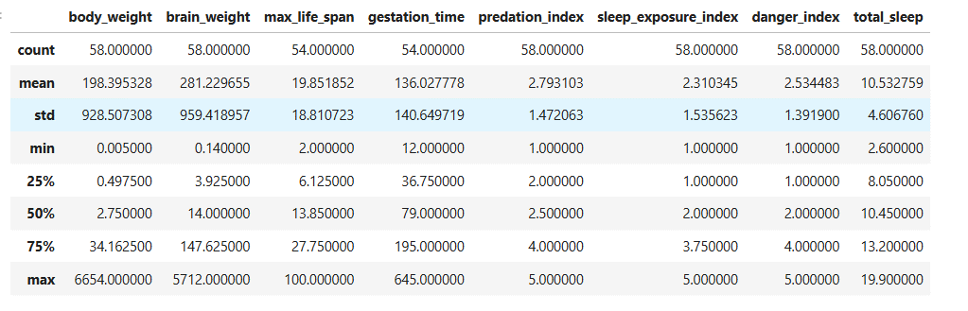
- Key Observation: Average total sleep across the sampled species is 10.53 hours/day, ranging from a minimum of 2.6 hours up to 19.9 hours.

4. Key Results & Correlation Analysis
A Pearson correlation matrix was computed to identify key factors influencing total sleep and survival metrics:
- Total Sleep vs. Danger/Predation Risk:
  - Sleep Exposure Index (r=−0.642): Strongest negative correlation with total sleep. Animals more exposed to predators during sleep sleep significantly less.
  - Gestation Time (r=−0.631): Strong negative correlation with total sleep. Longer gestation periods correspond to less daily sleep.
  - Danger Index (r=−0.588): Strong negative correlation. Higher overall danger index leads to reduced sleep hours.
  - Predation Index (r=−0.396): Moderate negative correlation.
- Physical Characteristics & Relationships:
  - Body Weight & Brain Weight (r=0.934): Extremely strong positive correlation.
  - Predation Index & Danger Index (r=0.928): Near-perfect positive linear relationship, indicating higher predation exposure directly drives the overall danger rating for species.

5. Key Takeaways & Conclusions
- Ecological Safety Dictates Sleep: Environmental threat variables (Danger, Exposure, and Predation) are the primary negative predictors of total sleep time in mammals.
- Body Size & Development: Species with longer gestation times and larger physical/brain sizes generally spend fewer hours sleeping per day compared to smaller species with shorter developmental cycles.

